Nang Thiri Wutyi

20113

10/21/2024

**Verilog Lab #4**

1. **1-bit NOT gate**

**Design module**

`timescale 1ns / 1ps // Specify time unit of 1 nanosecond and time precision of 1 picosecond

// 1-bit NOT gate using continuous assignment

module not_gate_cont (

input wire a, // 1-bit input

output wire y // 1-bit output

);

assign y = ~a; // Continuous assignment of NOT operation

endmodule

// 1-bit NOT gate using always block

module not_gate_always (

input wire a, // 1-bit input

output reg y // 1-bit output (reg type for always block)

);

always @(*) begin

y = ~a; // Assigning NOT operation inside always block

end

endmodule

**Testbench module**

`timescale 1ns / 1ps

module tb_not_gate();

// Declare inputs for the testbench

reg a;

// Declare outputs for both modules

wire y_cont;

wire y_always;

// Instantiate the not_gate_cont module

not_gate_cont u1 (

.a(a),

.y(y_cont)

);

// Instantiate the not_gate_always module

not_gate_always u2 (

.a(a),

.y(y_always)

);

// Testbench initial block

initial begin

// Enable VCD dumping for waveform generation

$dumpfile("dump.vcd"); // VCD file name

$dumpvars(0, tb_not_gate); // Dump all variables in tb_not_gate

// Display results in the console

$monitor("Time=%0t | a=%b | y_cont=%b | y_always=%b", $time, a, y_cont, y_always);

// Test case 1: a = 0

a = 1'b0;

#10;

// Test case 2: a = 1

a = 1'b1;

#10;

// Finish simulation

$finish;

end

endmodule

**Results**

**[2024-10-22 02:44:57 UTC] iverilog '-Wall' '-g2012' design.sv testbench.sv && unbuffer vvp a.out**

**VCD info: dumpfile dump.vcd opened for output.**

**Time=0 | a=0 | y_cont=1 | y_always=1**

**Time=10000 | a=1 | y_cont=0 | y_always=0**

**testbench.sv:41: $finish called at 20000 (1ps)**

**Done**

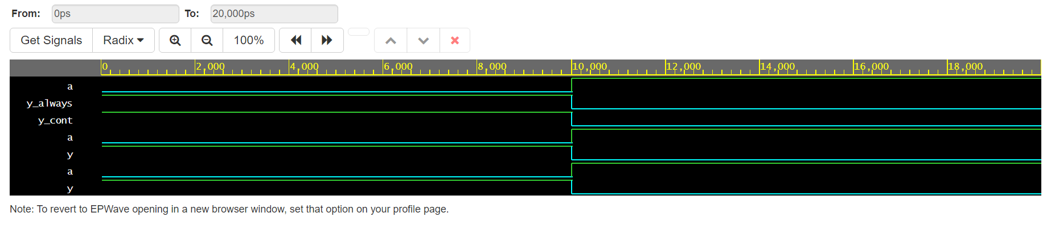

1. **2-bits AND gate**

**Design module**

`timescale 1ns / 1ps // Time unit is 1ns, and time precision is 1ps

// 2-bit AND gate using continuous assignment

module and_gate_cont (

input wire [1:0] a, // 2-bit input

input wire [1:0] b, // 2-bit input

output wire [1:0] y // 2-bit output

);

assign y = a & b; // Continuous assignment for AND operation

endmodule

// 2-bit AND gate using always block

module and_gate_always (

input wire [1:0] a, // 2-bit input

input wire [1:0] b, // 2-bit input

output reg [1:0] y // 2-bit output (reg type for always block)

);

always @(*) begin

y = a & b; // AND operation inside always block

end

endmodule

**Testbench module**

`timescale 1ns / 1ps // Time unit is 1ns, and time precision is 1ps

module tb_and_gate();

// Declare inputs for the testbench

reg [1:0] a;

reg [1:0] b;

// Declare outputs for both modules

wire [1:0] y_cont;

wire [1:0] y_always;

// Instantiate the and_gate_cont module

and_gate_cont u1 (

.a(a),

.b(b),

.y(y_cont)

);

// Instantiate the and_gate_always module

and_gate_always u2 (

.a(a),

.b(b),

.y(y_always)

);

// Testbench initial block

initial begin

// Enable VCD dumping for waveform generation

$dumpfile("dump.vcd");

$dumpvars(0, tb_and_gate);

// Display results in the console

$monitor("Time=%0t | a=%b | b=%b | y_cont=%b | y_always=%b", $time, a, b, y_cont, y_always);

// Test case 1: a = 00, b = 00

a = 2'b00; b = 2'b00;

#10;

// Test case 2: a = 01, b = 10

a = 2'b01; b = 2'b10;

#10;

// Test case 3: a = 11, b = 11

a = 2'b11; b = 2'b11;

#10;

// Test case 4: a = 10, b = 01

a = 2'b10; b = 2'b01;

#10;

// Finish simulation

$finish;

end

endmodule

**Results**

**[2024-10-22 02:53:33 UTC] iverilog '-Wall' '-g2012' design.sv testbench.sv && unbuffer vvp a.out**

**VCD info: dumpfile dump.vcd opened for output.**

**Time=0 | a=00 | b=00 | y_cont=00 | y_always=00**

**Time=10000 | a=01 | b=10 | y_cont=00 | y_always=00**

**Time=20000 | a=11 | b=11 | y_cont=11 | y_always=11**

**Time=30000 | a=10 | b=01 | y_cont=00 | y_always=00**

**testbench.sv:52: $finish called at 40000 (1ps)**

**Done**

1. **2-bits OR gate**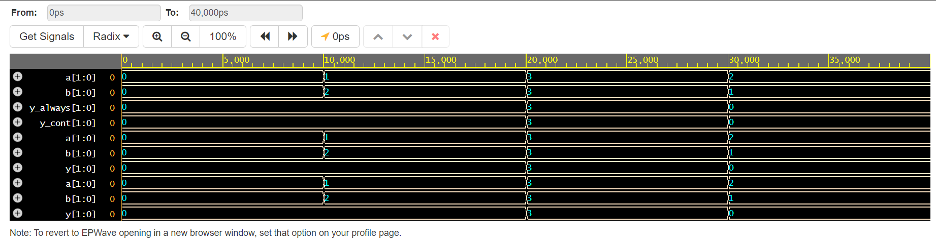

**Design module**

`timescale 1ns / 1ps // Time unit is 1ns, and time precision is 1ps

module tb_or_gate();

// Declare inputs for the testbench

reg [1:0] a;

reg [1:0] b;

// Declare outputs for both modules

wire [1:0] y_cont;

wire [1:0] y_always;

// Instantiate the or_gate_cont module

or_gate_cont u1 (

.a(a),

.b(b),

.y(y_cont)

);

// Instantiate the or_gate_always module

or_gate_always u2 (

.a(a),

.b(b),

.y(y_always)

);

// Testbench initial block

initial begin

// Enable VCD dumping for waveform generation

$dumpfile("dump.vcd");

$dumpvars(0, tb_or_gate);

// Display results in the console

$monitor("Time=%0t | a=%b | b=%b | y_cont=%b | y_always=%b", $time, a, b, y_cont, y_always);

// Test case 1: a = 00, b = 00

a = 2'b00; b = 2'b00;

#10;

// Test case 2: a = 01, b = 10

a = 2'b01; b = 2'b10;

#10;

// Test case 3: a = 11, b = 11

a = 2'b11; b = 2'b11;

#10;

// Test case 4: a = 10, b = 01

a = 2'b10; b = 2'b01;

#10;

// Finish simulation

$finish;

end

endmodule

**Testbench module**

`timescale 1ns / 1ps // Time unit is 1ns, and time precision is 1ps

module tb_or_gate();

// Declare inputs for the testbench

reg [1:0] a;

reg [1:0] b;

// Declare outputs for both modules

wire [1:0] y_cont;

wire [1:0] y_always;

// Instantiate the or_gate_cont module

or_gate_cont u1 (

.a(a),

.b(b),

.y(y_cont)

);

// Instantiate the or_gate_always module

or_gate_always u2 (

.a(a),

.b(b),

.y(y_always)

);

// Testbench initial block

initial begin

// Enable VCD dumping for waveform generation

$dumpfile("dump.vcd");

$dumpvars(0, tb_or_gate);

// Display results in the console

$monitor("Time=%0t | a=%b | b=%b | y_cont=%b | y_always=%b", $time, a, b, y_cont, y_always);

// Test case 1: a = 00, b = 00

a = 2'b00; b = 2'b00;

#10;

// Test case 2: a = 01, b = 10

a = 2'b01; b = 2'b10;

#10;

// Test case 3: a = 11, b = 11

a = 2'b11; b = 2'b11;

#10;

// Test case 4: a = 10, b = 01

a = 2'b10; b = 2'b01;

#10;

// Finish simulation

$finish;

end

endmodule

**Results**

**[2024-10-22 03:09:38 UTC] iverilog '-Wall' '-g2012' design.sv testbench.sv && unbuffer vvp a.out**

**VCD info: dumpfile dump.vcd opened for output.**

**Time=0 | a=00 | b=00 | y_cont=00 | y_always=00**

**Time=10000 | a=01 | b=10 | y_cont=11 | y_always=11**

**Time=20000 | a=11 | b=11 | y_cont=11 | y_always=11**

**Time=30000 | a=10 | b=01 | y_cont=11 | y_always=11**

**testbench.sv:52: $finish called at 40000 (1ps)**

**Done**

1. **2-bits NAND gate**

**Design module**

`timescale 1ns / 1ps // Time unit is 1ns, and time precision is 1ps

// 2-bit NAND gate using continuous assignment

module nand_gate_cont (

input wire [1:0] a, // 2-bit input

input wire [1:0] b, // 2-bit input

output wire [1:0] y // 2-bit output

);

assign y = ~(a & b); // Continuous assignment for NAND operation

endmodule

`timescale 1ns / 1ps // Time unit is 1ns, and time precision is 1ps

// 2-bit NAND gate using always block

module nand_gate_always (

input wire [1:0] a, // 2-bit input

input wire [1:0] b, // 2-bit input

output reg [1:0] y // 2-bit output (reg type for always block)

);

always @(*) begin

y = ~(a & b); // NAND operation inside always block

end

endmodule

**Testbench module**

`timescale 1ns / 1ps // Time unit is 1ns, and time precision is 1ps

module tb_nand_gate();

// Declare inputs for the testbench

reg [1:0] a;

reg [1:0] b;

// Declare outputs for both modules

wire [1:0] y_cont;

wire [1:0] y_always;

// Instantiate the nand_gate_cont module

nand_gate_cont u1 (

.a(a),

.b(b),

.y(y_cont)

);

// Instantiate the nand_gate_always module

nand_gate_always u2 (

.a(a),

.b(b),

.y(y_always)

);

// Testbench initial block

initial begin

// Enable VCD dumping for waveform generation

$dumpfile("dump.vcd");

$dumpvars(0, tb_nand_gate);

// Display results in the console

$monitor("Time=%0t | a=%b | b=%b | y_cont=%b | y_always=%b", $time, a, b, y_cont, y_always);

// Test case 1: a = 00, b = 00

a = 2'b00; b = 2'b00;

#10;

// Test case 2: a = 01, b = 10

a = 2'b01; b = 2'b10;

#10;

// Test case 3: a = 11, b = 11

a = 2'b11; b = 2'b11;

#10;

// Test case 4: a = 10, b = 01

a = 2'b10; b = 2'b01;

#10;

// Finish simulation

$finish;

end

endmodule

**Results**

**[2024-10-22 03:18:51 UTC] iverilog '-Wall' '-g2012' design.sv testbench.sv && unbuffer vvp a.out**

**VCD info: dumpfile dump.vcd opened for output.**

**Time=0 | a=00 | b=00 | y_cont=11 | y_always=11**

**Time=10000 | a=01 | b=10 | y_cont=11 | y_always=11**

**Time=20000 | a=11 | b=11 | y_cont=00 | y_always=00**

**Time=30000 | a=10 | b=01 | y_cont=11 | y_always=11**

**testbench.sv:52: $finish called at 40000 (1ps)**

**Done**

1. **2-bits NOR gate**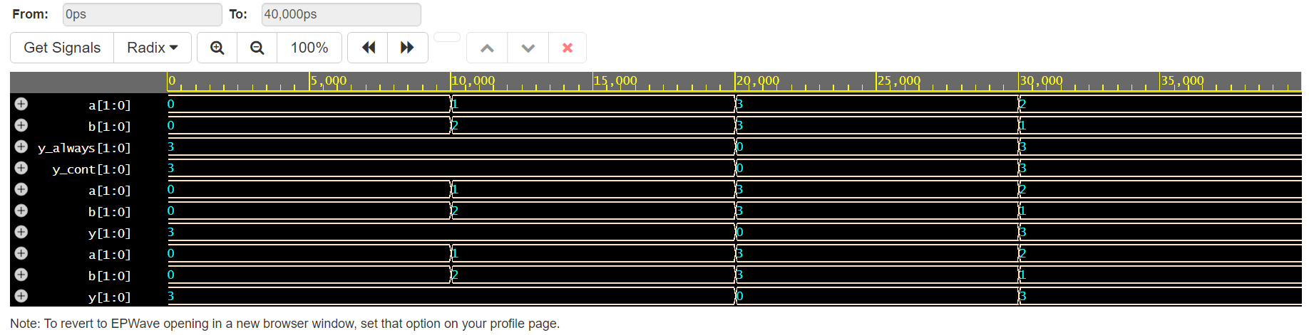

**Design module**

`timescale 1ns / 1ps // Time unit is 1ns, and time precision is 1ps

module tb_nor_gate();

// Declare inputs for the testbench

reg [1:0] a;

reg [1:0] b;

// Declare outputs for both modules

wire [1:0] y_cont;

wire [1:0] y_always;

// Instantiate the nor_gate_cont module

nor_gate_cont u1 (

.a(a),

.b(b),

.y(y_cont)

);

// Instantiate the nor_gate_always module

nor_gate_always u2 (

.a(a),

.b(b),

.y(y_always)

);

// Testbench initial block

initial begin

// Enable VCD dumping for waveform generation

$dumpfile("dump.vcd");

$dumpvars(0, tb_nor_gate);

// Display results in the console

$monitor("Time=%0t | a=%b | b=%b | y_cont=%b | y_always=%b", $time, a, b, y_cont, y_always);

// Test case 1: a = 00, b = 00

a = 2'b00; b = 2'b00;

#10;

// Test case 2: a = 01, b = 10

a = 2'b01; b = 2'b10;

#10;

// Test case 3: a = 11, b = 11

a = 2'b11; b = 2'b11;

#10;

// Test case 4: a = 10, b = 01

a = 2'b10; b = 2'b01;

#10;

// Finish simulation

$finish;

end

endmodule

**Testbench module**

`timescale 1ns / 1ps // Time unit is 1ns, and time precision is 1ps

module tb_nor_gate();

// Declare inputs for the testbench

reg [1:0] a;

reg [1:0] b;

// Declare outputs for both modules

wire [1:0] y_cont;

wire [1:0] y_always;

// Instantiate the nor_gate_cont module

nor_gate_cont u1 (

.a(a),

.b(b),

.y(y_cont)

);

// Instantiate the nor_gate_always module

nor_gate_always u2 (

.a(a),

.b(b),

.y(y_always)

);

// Testbench initial block

initial begin

// Enable VCD dumping for waveform generation

$dumpfile("dump.vcd");

$dumpvars(0, tb_nor_gate);

// Display results in the console

$monitor("Time=%0t | a=%b | b=%b | y_cont=%b | y_always=%b", $time, a, b, y_cont, y_always);

// Test case 1: a = 00, b = 00

a = 2'b00; b = 2'b00;

#10;

// Test case 2: a = 01, b = 10

a = 2'b01; b = 2'b10;

#10;

// Test case 3: a = 11, b = 11

a = 2'b11; b = 2'b11;

#10;

// Test case 4: a = 10, b = 01

a = 2'b10; b = 2'b01;

#10;

// Finish simulation

$finish;

end

endmodule

**Results**

**[2024-10-22 03:25:56 UTC] iverilog '-Wall' '-g2012' design.sv testbench.sv && unbuffer vvp a.out**

**VCD info: dumpfile dump.vcd opened for output.**

**Time=0 | a=00 | b=00 | y_cont=11 | y_always=11**

**Time=10000 | a=01 | b=10 | y_cont=00 | y_always=00**

**Time=20000 | a=11 | b=11 | y_cont=00 | y_always=00**

**Time=30000 | a=10 | b=01 | y_cont=00 | y_always=00**

**testbench.sv:52: $finish called at 40000 (1ps)**

**Done**

1. **2-bits XOR gate**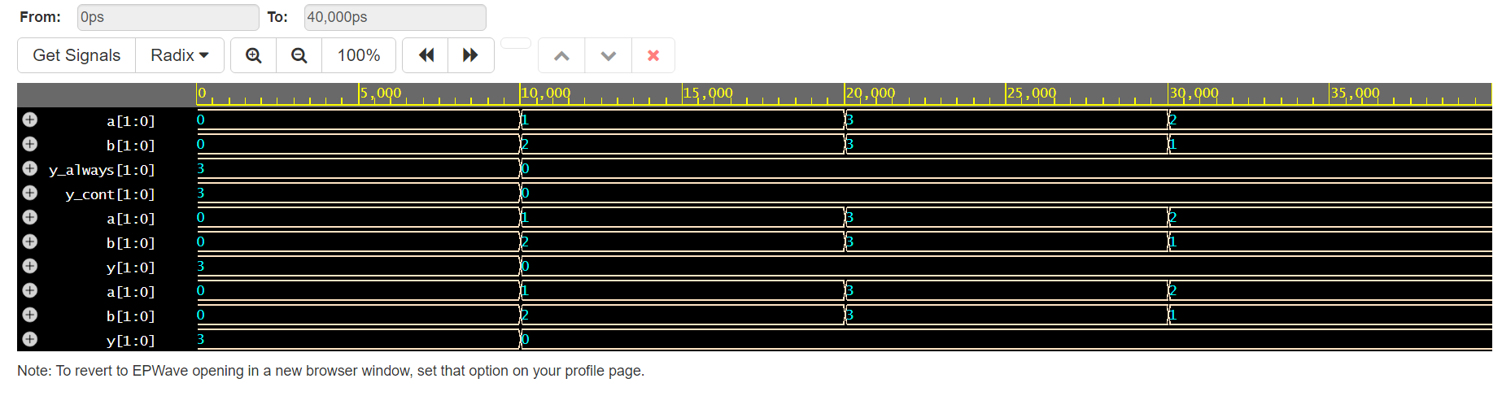

**Design module**

`timescale 1ns / 1ps // Time unit is 1ns, and time precision is 1ps

// 2-bit XOR gate using continuous assignment

module xor_gate_cont (

input wire [1:0] a, // 2-bit input

input wire [1:0] b, // 2-bit input

output wire [1:0] y // 2-bit output

);

assign y = a ^ b; // Continuous assignment for XOR operation

endmodule

`timescale 1ns / 1ps // Time unit is 1ns, and time precision is 1ps

// 2-bit XOR gate using always block

module xor_gate_always (

input wire [1:0] a, // 2-bit input

input wire [1:0] b, // 2-bit input

output reg [1:0] y // 2-bit output (reg type for always block)

);

always @(*) begin

y = a ^ b; // XOR operation inside always block

end

endmodule

**Testbench module**

`timescale 1ns / 1ps // Time unit is 1ns, and time precision is 1ps

module tb_xor_gate();

// Declare inputs for the testbench

reg [1:0] a;

reg [1:0] b;

// Declare outputs for both modules

wire [1:0] y_cont;

wire [1:0] y_always;

// Instantiate the xor_gate_cont module

xor_gate_cont u1 (

.a(a),

.b(b),

.y(y_cont)

);

// Instantiate the xor_gate_always module

xor_gate_always u2 (

.a(a),

.b(b),

.y(y_always)

);

// Testbench initial block

initial begin

// Enable VCD dumping for waveform generation

$dumpfile("dump.vcd");

$dumpvars(0, tb_xor_gate);

// Display results in the console

$monitor("Time=%0t | a=%b | b=%b | y_cont=%b | y_always=%b", $time, a, b, y_cont, y_always);

// Test case 1: a = 00, b = 00

a = 2'b00; b = 2'b00;

#10;

// Test case 2: a = 01, b = 10

a = 2'b01; b = 2'b10;

#10;

// Test case 3: a = 11, b = 11

a = 2'b11; b = 2'b11;

#10;

// Test case 4: a = 10, b = 01

a = 2'b10; b = 2'b01;

#10;

// Finish simulation

$finish;

end

endmodule

**Results**

**[2024-10-22 03:31:23 UTC] iverilog '-Wall' '-g2012' design.sv testbench.sv && unbuffer vvp a.out**

**VCD info: dumpfile dump.vcd opened for output.**

**Time=0 | a=00 | b=00 | y_cont=00 | y_always=00**

**Time=10000 | a=01 | b=10 | y_cont=11 | y_always=11**

**Time=20000 | a=11 | b=11 | y_cont=00 | y_always=00**

**Time=30000 | a=10 | b=01 | y_cont=11 | y_always=11**

**testbench.sv:52: $finish called at 40000 (1ps)**

**Done**

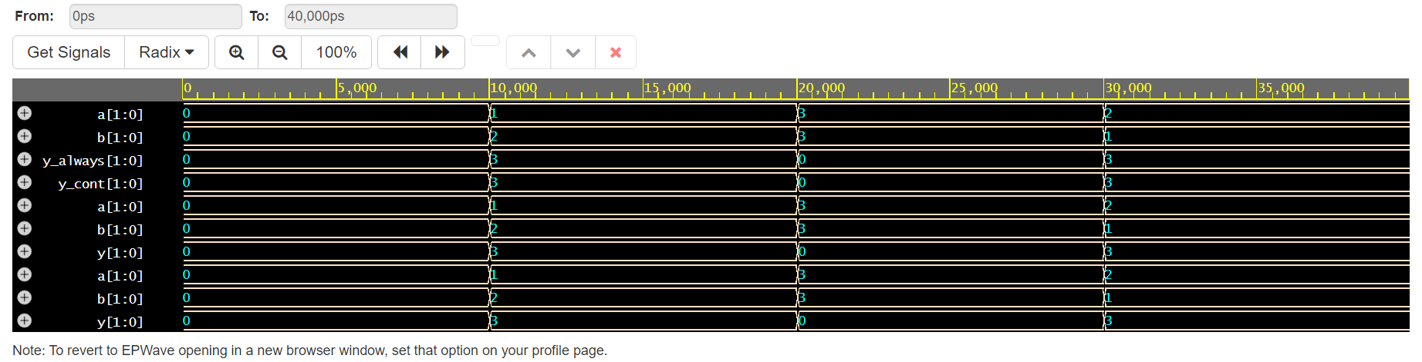

1. **2-bits XNOR gate**

**Design module**

`timescale 1ns / 1ps // Time unit is 1ns, and time precision is 1ps

// 2-bit XNOR gate using continuous assignment

module xnor_gate_cont (

input wire [1:0] a, // 2-bit input

input wire [1:0] b, // 2-bit input

output wire [1:0] y // 2-bit output

);

assign y = ~(a ^ b); // Continuous assignment for XNOR operation

endmodule

`timescale 1ns / 1ps // Time unit is 1ns, and time precision is 1ps

// 2-bit XNOR gate using always block

module xnor_gate_always (

input wire [1:0] a, // 2-bit input

input wire [1:0] b, // 2-bit input

output reg [1:0] y // 2-bit output (reg type for always block)

);

always @(*) begin

y = ~(a ^ b); // XNOR operation inside always block

end

endmodule

**Testbench module**

`timescale 1ns / 1ps // Time unit is 1ns, and time precision is 1ps

module tb_xnor_gate();

// Declare inputs for the testbench

reg [1:0] a;

reg [1:0] b;

// Declare outputs for both modules

wire [1:0] y_cont;

wire [1:0] y_always;

// Instantiate the xnor_gate_cont module

xnor_gate_cont u1 (

.a(a),

.b(b),

.y(y_cont)

);

// Instantiate the xnor_gate_always module

xnor_gate_always u2 (

.a(a),

.b(b),

.y(y_always)

);

// Testbench initial block

initial begin

// Enable VCD dumping for waveform generation

$dumpfile("dump.vcd");

$dumpvars(0, tb_xnor_gate);

// Display results in the console

$monitor("Time=%0t | a=%b | b=%b | y_cont=%b | y_always=%b", $time, a, b, y_cont, y_always);

// Test case 1: a = 00, b = 00

a = 2'b00; b = 2'b00;

#10;

// Test case 2: a = 01, b = 10

a = 2'b01; b = 2'b10;

#10;

// Test case 3: a = 11, b = 11

a = 2'b11; b = 2'b11;

#10;

// Test case 4: a = 10, b = 01

a = 2'b10; b = 2'b01;

#10;

// Finish simulation

$finish;

end

endmodule

**Results**

**[2024-10-22 03:36:02 UTC] iverilog '-Wall' '-g2012' design.sv testbench.sv && unbuffer vvp a.out**

**VCD info: dumpfile dump.vcd opened for output.**

**Time=0 | a=00 | b=00 | y_cont=11 | y_always=11**

**Time=10000 | a=01 | b=10 | y_cont=00 | y_always=00**

**Time=20000 | a=11 | b=11 | y_cont=11 | y_always=11**

**Time=30000 | a=10 | b=01 | y_cont=00 | y_always=00**

**testbench.sv:52: $finish called at 40000 (1ps)**

**Done**

